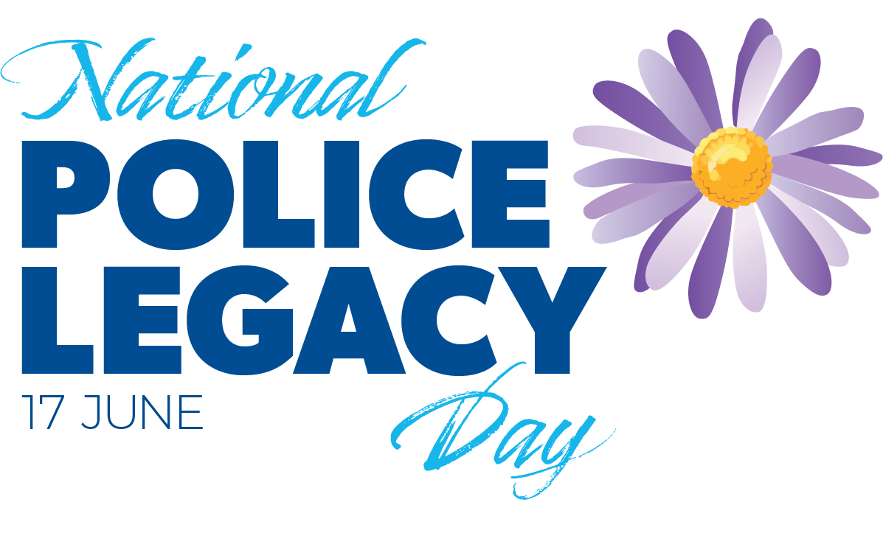

First National Police Legacy Day celebrates life-changing work that started in Queensland

15 June, 2025

-EMBARGOED UNTIL 6AM SUNDAY 15 JUNE, 2025-

This Tuesday, Australia will celebrate National Police Legacy Day, a day to acknowledge the incredible work of Police Legacy charities across the country, which all started here in Queensland 54 years ago.

More than half a century ago, a conversation on a Brisbane bus proved critical to shaping Queensland Police Legacy into what it is today. Since then, the charity has gone on to support hundreds of police families facing tragedy.

This Tuesday, 17 June, is the inaugural National Police Legacy Day. 17 June pays tribute to Queensland’s pioneering role in founding the country’s first Police Legacy organisation on 17 June, 1971.

In the very early 1970s, a small group of Queensland police officers decided that the informal tradition of passing a hat around on pay day to help grieving police families was inadequate to support those in need. Something formal was required. According to Bob Burns, a retired Queensland Police Service Inspector who dedicated 25 years to the Queensland Police Legacy Board, including two stints as President: “It became obvious we needed to formalise something to support widows and children.”

The late Ron Youels Senior, a QPS Inspector, played a key role in establishing Queensland Police Legacy. Ron Senior was Queensland Police Legacy’s Founding Secretary and dedicated 20 years of his life to the charity.

As Ron’s son, Ron Youels Junior, recalled, his father was a man of action. Once he identified a problem, he would talk to whoever would listen to find a solution.

The group of police officers had formally established Queensland Police Legacy on 17 June, 1971, but they need a way of funding the charity.

As luck would have it, Ron Senior caught the bus to work each day from Wavell Heights to Brisbane in his freshly pressed police uniform with the private secretary to then Queensland Premier Sir Joh Bjelke-Petersen.

During one of these rides in 1972, Ron Senior shared the concept of Queensland Police Legacy and the barrier posed by Treasury, which had declined to implement a payroll deduction scheme to help fund the charity. On the bus, the private secretary said to Ron: 'Leave it with me.' Within two weeks, the decision was reversed, giving Queensland Police Legacy critical access to a support network that enabled it to grow into the charity it is today.

Another key figure in getting Police Legacy off the ground was the late Frank Atwood, Queensland Police Legacy's Founding President.

His daughter, Janette Cranstoun, said she remembered her father saying the idea was based on the Army Legacy concept. Frank, a First-Class Inspector, was passionate about caring for children in need, and in his lifetime made more than 11,000 wooden toys for children all over the world. He was awarded the MBE (Member of the British Empire) by Queen Elizabeth II for his services to underprivileged children.

“He had a workshop under our house. He was very community-minded and looking to help underprivileged children who needed a little bit of joy in their life at Christmas,” Mrs Cranstoun said.

From its modest beginnings, there are now eight Police Legacy organisations across Australia that support Police and their families.

One of the first Police Legatees to receive support from Queensland Police Legacy was Dr Patricia (Trish) O’Connor.

Her father was a Police Officer and died suddenly at work aged just 49 from cardiac-related issues in 1973.

Dr O’Connor, now 70, fondly recalls Queensland Police Legacy providing her with a doctor’s bag when she graduated from medical school in 1977. She went on to practice medicine and continues her work as a general practitioner to this day.

Dr O’Connor said the Queensland Police Legacy scheme was in its infancy when her father passed away and had come a long way since then, now offering legatees a great deal more support.

Queensland Police Legacy has stood alongside many Queensland families over the decades — including the Forresters.

In May 2004, Queensland Police Service Senior Sergeant Jim Forrester had a massive heart attack at work and died aged just 48.

Queensland Police Legacy has ensured his widow, Janelle Forrester, and their three children, Ally, Tyrone and Beaudyne, have been looked after since his passing.

Ally was just six when her father died, and her brother Beaudyne was aged 10 and Tyrone was 13.

“I'd already known about Police Legacy because I had worked for the Queensland Police Service as an administration officer. I knew that it existed but never dreamed I would need any assistance,” Janelle said.

“I remember them helping with the school fees. They said: ‘Don't stress, we've got it all taken care of. You don't have to worry about those bills, which was great a financial relief, because we were a one income family. I wasn’t working. I was a stay-at-home mother with three children,” Janelle said.

Queensland Police Legacy has a focus on providing education for children who are Police Legatees. They helped pay Ally’s way through law school, contributing to both fees and textbooks.

“It took the financial stress from both myself and mum so I could just focus on my studies, and it gave me the tools to complete my degree, and I got Honors. As a result of being able to do so well in my degree, I was able to achieve placements at highly desirable legal departments,” Ally said.

She now works for Queensland Police Service herself as a Principal Strategy and Governance Officer, which involves developing and reviewing policies.

“I now work with a lot of Dad’s colleagues. Every police officer that worked with him always notes his dedication to policing, his kindness and loyalty to colleagues and his love to have a chat,” Ally, now 27, said.

“I would hand on heart say I wouldn't be able to pursue all the opportunities I have been afforded without Police Legacy.”

Janelle explained that Queensland Police Legacy helped throughout all three of her children's educations, not only with school fees but also with uniforms, excursions, and extracurricular activities such as dancing for Ally. They supported Tyrone and Beaudyne with their TAFE fees and the cost of tools for their trades.

“We're talking about financial support they provided, but Police Legacy also provided practical and emotional support to us. We went on yearly holidays. We went to Christmas parties with other Queensland Police families,” Ally said.

Janelle and her kids went on up to 15 Police Legacy holidays as a family over the years.

“I think it was great for the children, because they got to see that they weren't alone. There were other families in the same circumstances that didn't have a mum or a dad, children that were older and children who were younger. Some children never even got to meet their fathers because their fathers had passed away before they were born,” Janelle said.

“Any donation, whether small or big, will change a family's life,” Ally said.

Since its establishment in 1971, Queensland Police Legacy has provided support to 285 families and 507 dependent legatee children.

Queensland Police Legacy Board President Detective Senior Sergeant Kent Ellis spoke about the importance of National Police Legacy Day.

“We hope that through National Police Legacy Day we can celebrate and highlight the life-changing work being done by Police Legacy organisations around the country,” Detective Senior Sergeant Ellis said.

“The mission of Police Legacy is not only to honour the memory of those who served, but to ensure that the lives of those they leave behind are not defined by tragedy, but shaped by hope, resilience, and possibility.”

Assistant Minister for Productivity, Competition, Charities and Treasury the Hon Andrew Leigh MP officially launched National Police Legacy Day at Parliament House in Canberra.

“When tragedy strikes, Police Legacy is there – not just in the immediate aftermath, but in the months and years that follow. It provides emotional support, financial assistance, and – just as importantly – a deep sense of ongoing connection. These organisations check in, stay close, and remind families that they remain part of something larger,” Assistant Minister Leigh said.

The logo for National Police Legacy Day is inspired by the Michaelmas daisy. The Michaelmas daisy is the flower of St Michael, the patron saint of police who protects those who have sworn to serve and remembers those no longer with us.

If you’d like to buy a Police Legacy Daisy pin, please email [info@policelegacyqld.org.au](mailto:info@policelegacyqld.org.au) stating how many pins you require and a postal address.

***Full media kit containing photos and video available at: www.npld.org.au***

-Ends-

**Note for editors**

* National Police Legacy Day is a day of celebration of the work of Police Legacy charities. It is separate from Police Remembrance Day, which is a day of mourning and reflection.