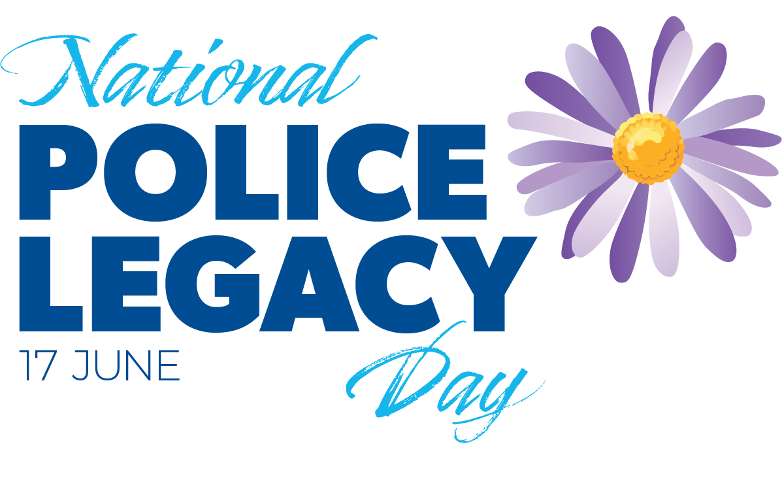

First National Police Legacy Day celebrates life-changing work

15 June, 2025

-EMBARGOED UNTIL 6AM SUNDAY 15 JUNE, 2025-

When Cleo Darke became a mum six weeks ago, there was no question what one of her baby boy’s middle names would be: Simon — in honour of her late father, Constable Simon Darke. Simon was a much-loved Tasmania Police officer who died by suicide in 2019.

Cleo was just 16 at the time. Today, at 22, she’s sharing her story for National Police Legacy Day to recognise the organisation that helped her through the darkest period of her life. With the support of Police Legacy Tasmania, she’s found connection, healing, and hope — and says she wouldn’t be where she is today without them.

“My father committed suicide in early February 2019, on my first day of year 10. He was on duty at the time,” Cleo, now 22, said.

Cleo was just 16 when her Dad, Constable Simon Darke passed away. He was 45.

She spent time living with her beloved Dad and her two younger half-sisters in Midway Point. Since then, with the support of Police Legacy Tasmania, she has rebuilt her confidence and made lifelong friends to lean on.

It was some time after her father’s passing that Cleo actively joined Police Legacy Tasmania activities such as camps, partly due to COVID-19.

“But it was more about me also having the time to grieve and get over it in the beginning and then start to come out of the hole that I had dug myself into mentally and Police Legacy was a pretty big part of getting me out of that,” Cleo said.

“Just knowing that they were there, not necessarily relying on them for anything or reaching out to get anything but just knowing that they were there if I needed them, that was the biggest reassurance I could have asked for. It took the pressure off in so many aspects.”

Cleo said when she was ready to start getting back into activities like sports, Police Legacy Tasmania was there to help cover costs.

“I relied on my father a lot financially. Coming back into sport was a large part of my recovery from my father's death. I ended up committing to touch football about five times a week, playing and refereeing and getting outside and moving my body, and that was what my Dad had encouraged. And I found that that was the best way for me to recover from his death.”

Cleo was given the opportunity to attend Police Legacy camps alongside young people who had experienced similar challenges to her.

“Something that came to me after my Dad's death. It was about maybe six months later, I was sitting in bed when I realised I wouldn't have anyone to walk me down the aisle,” she said.

“I had a bit of a hard time after I realised that and then going away (to the Police Legacy camp) and speaking to other Police Legatees that had also lost their fathers, and they had had the same thought. It was reassuring that I wasn't being a sook or that maybe one of them could walk me down the aisle.”

Cleo talked about feeling incredibly isolated after her father’s death.

“I was able to rely on touch football to get me out of the house, and I was able to rely on people for support. But then to kind of accept it (my father’s death), and understand that I wasn't alone in my thoughts, that's something that I wouldn't have been able to get through if Police Legacy didn't exist.

“So, I can say that a lot of my recovery was as a result of connecting with these other Police Legatees to compare stories and to make sure that we weren’t alone.”

Police Legacy Tasmania paid for Cleo to hike the Kokoda Track, something she did with other Police Legatees and Police Legacy Tasmania chairperson Theresa Dilger.

“It was hard, is probably the only word I could use to describe it, and life-changing would probably be the other one,” Cleo said.

“You know, the track alone kind of made me realise just how strong I am.”

Cleo has found new strength as a mother to her six-week-old son, Clark Simon John.

His middle names are a tribute to his two grandfathers.

“I think Dad would be really upset that he's missing out on this (having a grandson). He was very much a family man. He loved babies and he was great with me and my sisters.”

Cleo recently accompanied her partner Lachlan, who is a Police Constable, and their newborn son to the Tasmania Police Academy.

“I was sitting in the gymnasium of the Police Academy and was looking around, realising that my father had brought me there when he was in the Police Academy. And I thought it was really sweet that my son is now having the same experience with his father,” Cleo said.

Before taking maternity leave, Cleo worked in the police radio room as a civilian dispatcher and triple zero call taker.

“You can't put a value on it (Police Legacy’s support). Without it, I'd be walking down an entirely different path in terms of my recovery from my Dad's death.”

National Police Legacy Day will be celebrated every year on 17 June. Police Legacy Tasmania was established in 2018.

Police Legacy Tasmania support services range from social activities to education and career grants, providing comfort, connection, and practical assistance to families.

Police Legacy Tasmania Chairperson Theresa Dilger highlighted the significance of the day.

“We hope that through National Police Legacy Day we can celebrate and shine a light on the life-changing work being done by Police Legacy organisations around the country,” Ms Dilger said.

Federal Assistant Minister for Productivity, Competition, Charities and Treasury The Hon Dr Andrew Leigh MP officially launched National Police Legacy Day at Parliament House in Canberra.

“When tragedy strikes, Police Legacy is there – not just in the immediate aftermath, but in the months and years that follow. It provides emotional support, financial assistance, and – just as importantly – a deep sense of ongoing connection. These organisations check in, stay close, and remind families that they remain part of something larger,” Assistant Minister Leigh said.

The logo for National Police Legacy Day is the Michaelmas daisy. The Michaelmas daisy is the flower of St Michael, the patron saint of police who protects those who have sworn to serve. We are proud to call it the Police Legacy Daisy.

Police Legacy Daisy pins are available for purchase at www.policelegacytas.org.au

If you or someone you know needs help, call Lifeline 13 11 14. Beyond Blue is available to speak 24/7 on 1300 22 4636. If someone’s life is in immediate danger, call 000.

-Ends-

***Full media kit containing photos and video available at:*** [***www.npld.org.au***](http://www.npld.org.au)

**Editor’s notes:**

* June 17 is the anniversary date of when the first Police Legacy organisation was established in Australia. Queensland Police Legacy started on 17 June, 1971. Each state and territory now has its own Police Legacy charity.
* National Police Legacy Day is a day of celebration. It is separate from Police Remembrance Day, which is a day of mourning.
* Cleo Darke’s partner Lachlan’s surname cannot be published due to his Policing work.
* Cleo and her son Clark are available to be in photos.